BİL 372
Sports Tournament Management System
Initial Database Model

Utku CEYLAN 221101067
Kıvanç TAŞ 221401022
Ali Berk KARAARSLAN 221401010
Mustafa TUFAN 221401029

The Sports Tournament Management System is designed to make organizing sports tournaments straightforward and highly efficient. This makes it easy for organizers to create tournaments, access important data, keep everything running smoothly, and make informed decisions along the way. The ER Diagram of Sports Tournament Management System is as shown in the figure below. A higher resolution format (draw.io version) is also submitted through uzak.

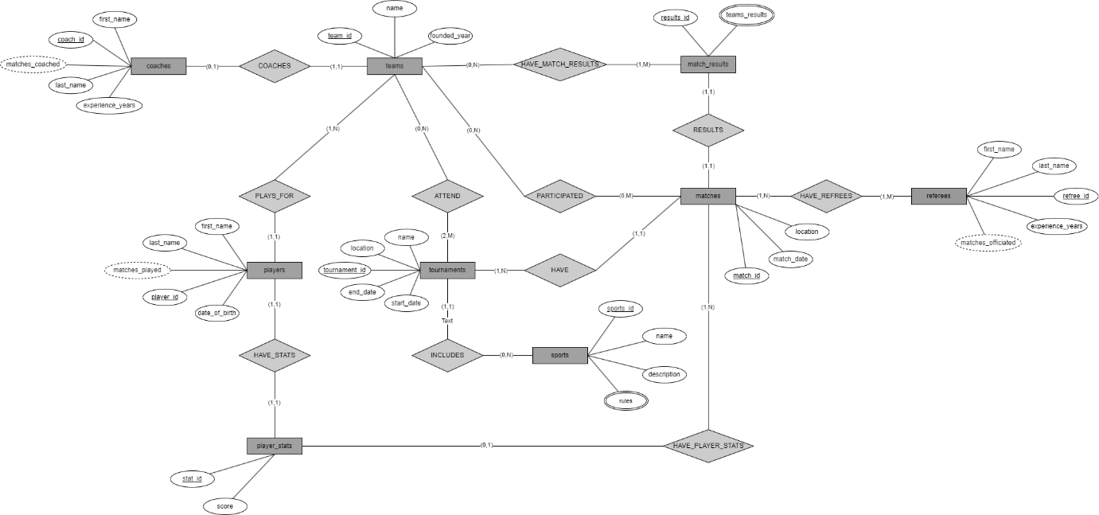

To clarify each table and respective attributes, we are listing all tables and attributes below.
1 Sports
- sport_id (Primary Key)
- name
- description
- rules (JSON)
2 Tournaments
- tournament_id (Primary Key)
- name
- sport_id (Foreign Key referencing Sports)
- start_date
- end_date
- location
3 Teams
- team_id (Primary Key)
- name
- coach (Foreign Key referencing Coaches)
- founded_year
- tournament_id (Foreign Key referencing Tournaments)
4 Players
- player_id (Primary Key)
- first_name
- last_name
- date_of_birth
- matches_played (derived)
- team_id (Foreign Key referencing Teams)
5 Matches
- match_id (Primary Key)
- tournament_id (Foreign Key referencing Tournaments)
- participating_team_id (Foreign Key referencing Teams)
- referee_id (Foreign Key referencing Referees)
- match_date
- location
6 Player_Stats
- stat_id (Primary Key)
- match_id (Foreign Key referencing Matches)
- player_id (Foreign Key referencing Players)
- score
7 Match_Results
- result_id (Primary Key)
- match_id (Foreign Key referencing Matches)
- teams_results (JSON)
- winner_team_id (Foreign Key referencing Teams)
8 Referees
- referee_id (Primary Key)
- first_name
- last_name
- experience_years
- matches_officiated (derived)
9 Coaches
- coach_id (Primary Key)
- first_name
- last_name
- experience_years
- currently_associated_team (Foreign Key referencing Teams)
- matches_coached (derived)

Our design choices for each entity are listed below.

SPORTS:
We want each sports entity to have name, description, unique ID, and rules attributes. The rules attribute is a multivalued attribute stored as JSON. The logic behind choosing JSON as the data type for rules is to ensure that our table will be able to store tournaments with very long rules without the need of rebuilding the architecture.

TOURNAMENTS:
We want each tournament to belong to a type of sports. Hence, we included a foreign key to the tournament table that references sports. Here the sports may be ‘long jump’, ‘football’, ‘chess’, ‘tennis’ or any sport. The table architecture is carefully created so that different sports can be represented using the existing tables. The tournament needs to have at least 2 competing teams and can have any number of teams competing. Similarly, at least 1 match needs to exist in the tournament, and many matches may exist.

TEAMS:
We want each team in a tournament to be unique; hence, the tournament_id foreign key in teams exists. A team can have at most 1 coach, it needs at least 1 player (some players may be considered substitutes), may attend a tournament or attend no tournaments at all. It may or may not participate in a match but can only participate in a match once. Each team has at least one match score; however, as a team may participate in more than one match, it can have any number of match_results (one for each match, many for many matches). Here, some tournaments (depending on the sport type) may have more than 2 teams competing. For example, an eSports match may involve 4 teams competing simultaneously for the total dominance of the game map.

PLAYERS:
A single player plays for a single team; a team has at least 1 but may have more players. A player has a single player stat in each match. We want to store each player’s player_stats in every different match. Hence the table “player_stats” references matches table and players table. It keeps track of matches_played, which are derivable from the matches table.

MATCHES:
A match can have many teams but single results for each team. A match has at least one team that participates in it, but not all teams need to participate in that match. Also, a match needs to have at least 1 referee. Similarly, a referee may participate in more than 1 match and has to participate in at least a single match.

PLAYER_STATS:
Each player has a player stat; a player stat may belong to a match or not. However, a match has all the stats of a player (hence it has the player_stats for each player in the match).

MATCH_RESULTS:
Each match result belongs to a match from the matches table, and each team may have more than one match_results (given that it can have more than one match). It has the teams_results attribute that shows results for each team that has participated in that match. There are no limits for teams participating in a single match; therefore, we have a multivalued attribute that holds the results of each team. Similar to the rules attribute of the sports table, we use JSON to store this multivalued attribute. Here the JSON file will be used to indicate winner and loser team(or teams) depending on specific tournament types. For example, for a football game, a JSON in the form of (2,3) for each goal score may be adequate, but for a game with 4 players, the (3, 2, 1 4) format for a JSON file would indicate that the winner is the third player. In this way, the JSON file storage allows us to include diverse sports and tournaments without changing database schema.

REFEREES:
Holds referee related information. A referee must be a referee for at least one match and may join more than one match. Similarly, each match must have at least one referee. It keeps track of matches_officiated, which are derivable from the matches table.

COACHES:
Each coach belongs to a team. Each team has only one coach. Holds coach related information. It keeps track of matches_coaches, which are derivable from the matches table.

